# Google Arabic Word Report

## Test environment

Google: [www.googe.com.eg](http://www.googe.com.eg)

*We must test Arabic words with this site. If we search an Arabic word with* [*www.google.com.hk*](http://www.google.com.hk)*, Google in HK will translate this word into an English word return English pages.*

Google doesn’t highlight the matched words as searching an English word. **We must find those matched words manually:**

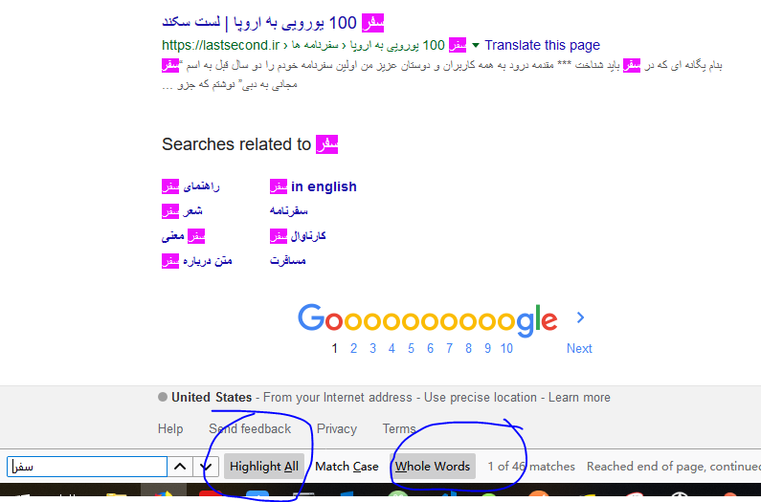

## Test data

Three verbs, سفر, سافري, أسافر

Three nouns, سيارة, سياراتهنا, سياراتكنا

## How I tested Google

I entered one word in Google and check how many kinds of inflection form are there in Google’s first 10 result pages.

## Accuracy comparison, Rosette vs Google

|  |  |  |
| --- | --- | --- |
| Verbs | Rosette | Google |
| سفر | 2.9% | 11.76% |
| سافري | 2.9% | 11.76% |
| أسافر | 94.1% | 32.35% |

These words are all from a base form “سفر” and an Arabic verb has 34 inflection form. So the perfect result when we search one of these three verbs, is the search engine returns all the **34 verbs.**

أسافر Rosette returned 32 words, Google returned 11 words

سفر and سافري, Rosette returned 1 word, Google returned 4 words

|  |  |  |
| --- | --- | --- |
| None | Rosette | Google |
| سيارة | 88.2% | 29.41% |
| سياراتهنا | None | Did you mean |
| سياراتكنا | None | Did you mean |

These nouns are all from a base form “سيارة”. This noun has 17 inflection form according to Ahmed’s report. So the perfect result when we search one of these three nouns, is the search engine returns all the **17 nouns**.

سيارة, Rosette returned 15 words, Google returned 5 words.

سياراتهنا and سياراتكنا, Rosette returned none, and Google reported “Did you mean”. *Google thought I was searching a misspelled word.*

## Reference

1. [Implementing Google's "Did you mean" Feature In Java](https://www.infoq.com/articles/lucene-did-you-mean)